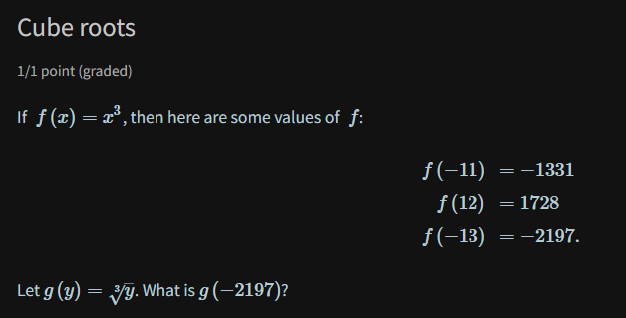

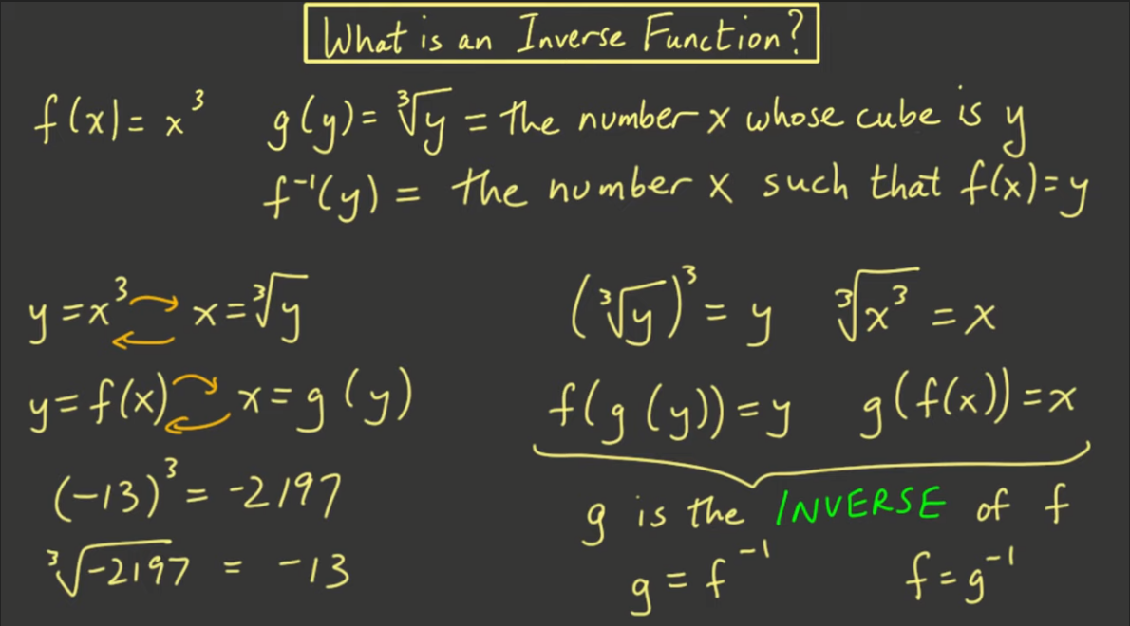

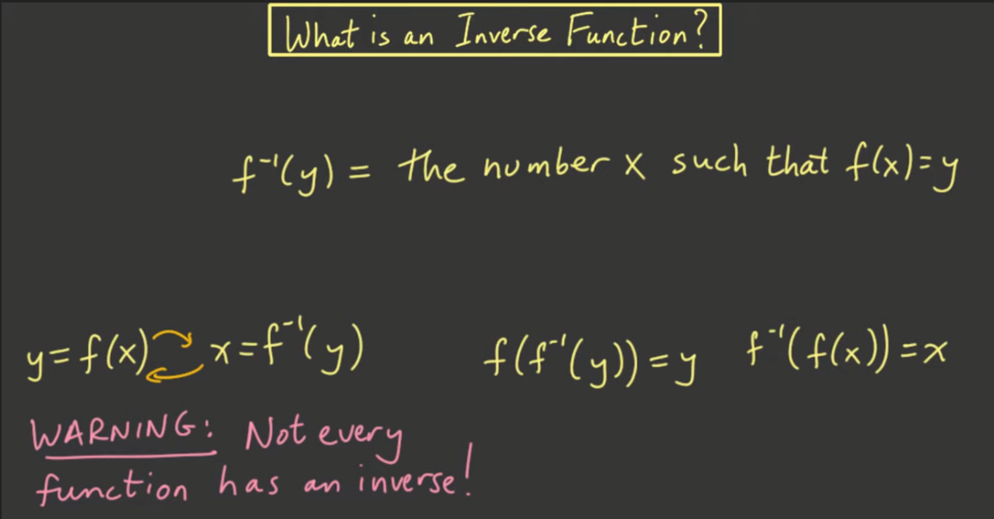

**4. Definition of inverse function**

If functions  f and g satisfy g(f(x))=x and  f(g(y))=y, then we say g is the inverse of  f, and denote it by  f−1. (Similarly,  f=g−1.)

If a function  f has an inverse function  f−1, then  f−1(b)=a if and only if  f(a)=b.

